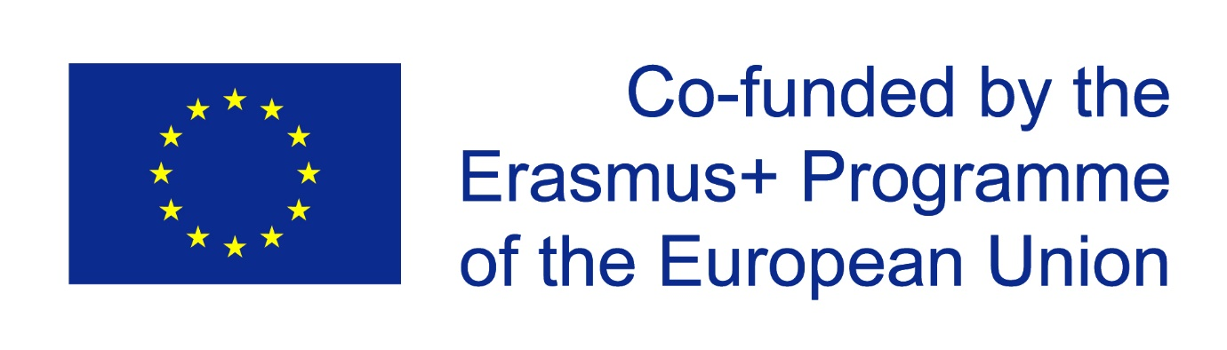

ENVIRONMENTAL CHARTER
Accepted on May 15 of 2020 by project partners

I PREAMBLE
This Charter is one of the outputs of the Erasmus + project Our Green European Town. The main purpose of the project has been to learn, become aware of and apply an environmentally friendly way of life. As a result of cooperation and exchange of ideas, we have written in this Charter our vision of what environmentally friendly functioning should look like in today's world.
The Charter is the result of a collaboration between students and teachers from the following schools: IES Biar (Spain, Biar), Profilirana matematicheska gymnasia “Konstantin Velichkov” (Bulgaria, Pazardzhik), Liceo Scientifico e Linguistico Statale Principe Umberto di Savoia (Italy, Catania), Escola Secundária de Loulé (Portugal, Loulé), Lycée Général et Technologique Marc Bloch (France, Bischheim), Pärnu Ühisgümnaasium (Estonia, Pärnu, coordinating school).
In creating the Charter, we have kept in mind that the natural environment needs protection from harmful human activities. This document reflects the ideas of the project partners and we do not claim to be universally valid. There are certainly other aspects that need to be highlighted in terms of environmental protection, both in Europe and on our planet as a whole.
We believe that environmentally sustainable behavior should be based on the following values:
- sustainable use of natural resources;
- scientific and truthful information on environmental problems;
- general environmental education;
- everyone's responsibility to preserve our environment;
- human health;
- welfare of different species;
- biodiversity;
- cooperation and citizen involvement in solving environmental problems;
- optimal ways to dispose of waste without harming the environment;
- green habits to preserve our environment;
- green-towns;
- sustainable energy;
- sustainable constructions;
- healthy development and wellbeing of younger generations;
- taking into account climate change.

Based on these values, we have formulated guiding principles, which we have written about in the next part of the Charter. We believe that following these guidelines, on the part of both individuals and countries, will contribute to environmental sustainability.
As citizens of the European Union, we have set out in the last part of the Charter what we expect from the European Union to promote the values and guiding principles emphasized in this document.

II GUIDING PRINCIPLES
- Activities that harm our natural environment must be prevented.

Natural resources are not unlimited and it is everyone's responsibility to consume them wisely. Renewable natural resources (water, air, forests, animals, fish stocks, etc.) must be used in such a way as to ensure the diversity of the natural environment.

Water is fundamental to human life. Droughts and water shortages jeopardize human health, agriculture and other activities. Treated wastewater must be reused for street washing, irrigation of gardens and golf courses, etc. Water retention systems should be build for periods of extreme precipitation to be used later on during drought periods.

- All information on climate change published in any media must be verifiable.

The media play a key role in promoting awareness and a positive attitude towards protection of health and the environment. They are entitled to adequate and accurate information and should be encouraged to communicate this information effectively to the public.

Climate misinformation can be found on mainstream media and social media, through a range of denialist arguments and fallacies. As a consequence, despite strong expert agreement, much of the public remains confused about the reality of human-induced global warming.
Therefore we believe it is necessary to create an observatory of experts to condemn false information on these issues.

- Conscious care for the environment begins with education.
A good idea for solving the environmental problems could be integrating ecology topics in the curriculum through all school subjects. This way, the children and young people will build habits to keep the environment clean and they will know the true value of nature. Moreover, it will be good in the kindergartens, all of the kids to have activities connected with recycling, planting different plants, playing games, in which they have to do something good for nature and the best competitor to win some nice award. This way from their early years, the kids will learn how to take care of the environment and what is more, they will know that good actions are always appreciated.

- Everyone has a responsibility to the environment.
Everyone's awareness of their responsibility to the environment must be promoted. We should ask ourselves, what are we doing to help create the conditions under which the world can deal with the big, systemic challenges that we face.

It is important to implement behavior that respects the environment around us, small behavior can lead to big changes.

- Activities that endanger human health or welfare of any other species on the planet should be avoided.
Climate change, together with other natural and human-made health stressors, influences human and wildlife health and disease in numerous ways. Habitat destruction brought on by the activity of humans threatens resident species and ecosystems.
Some existing health threats will intensify and new health threats will emerge. Not everyone is equally at risk. Important considerations include age, economic resources, and location.
It must be recognized that human activities are the result of a number of environmental changes, including species extinction and desertification.
It is important to learn from the collateral effects of the Covid-19 crisis. The crisis has shown the impact of human activities on the environment. Air pollution decreased drastically, and some endangered marine species (dolphins, tuna) reappeared on the coast as they felt a sudden change in human activity. It is important that we make the most of these learning for a better future and understand the impact of human activity and ways to improve our behavior.
- Every country must be prepared to the greatest possible extent for major crises that threaten people's lives and health.
One of the main lessons of the Covid-19 crisis has been the lack of preparedness to deal with pandemics. When faced with an emergency, every country is trying to find a suitable solution, and at the same time most countries were not ready to do so and have to face an emergency. There was a lot of international solidarity, but only to the extent that countries can afford it. In order to protect people's lives and health, we should be better prepared for major crises in the future. It is important for the EU to find common and transnational solutions.
- Human activities which drive to biodiversity loss and a threat to ecosystem sustainability, should be prevented.

Biodiversity, or the variety of all living beings on our planet, has been declining at an alarming rate in recent years, mainly due to human activities, such as land use changes, pollution and climate changes.

The world’s ecosystems, its living diversity and the goods and services it provides, are the life support systems upon which all of us depend. When scientists explore each ecosystem, they find countless such interactions, all honed by millions of years of evolution. If undamaged, this produces a finely balanced, healthy system which contributes to a healthy sustainable planet. Our long-term good health is currently at risk due to the continuing loss of biodiversity and the global degradation of ecosystems.

- Individuals, organizations, citizens' associations and countries around the world should work together to keep the planet clean.
If some individuals, associations, international organizations or countries are working to reduce pollution, then others should do the same, because we live on a common planet.
It is necessary to facilitate the involvement of citizens by taking concrete measures to support civic actions, rather than taking them for granted. Citizen groups and associations have developed widely in the past years to put sustainable development on the table. Local currencies have been created across Europe to encourage local and small-scale economy, citizens and companies have recourse to local goods and materials, whether it be in food, construction or housing equipment. On the local scale, common spaces are being set up for people living in a neighborhood to meet and share common practices.
Such concrete examples, very often initiated by citizens on a small scale must become the norm in the EU so that we may become an example to follow for the World. Concrete decisions must be taken by the institutions to encourage and develop such initiatives.
- Waste must be managed in such a way that it does not harm the environment.

There should be a rule that every city, town or village should have a rubbish bin about every 200 meters. This is problematic because some villages or small towns do not have enough rubbish bins, which again leads to being thrown out of the street bin. There should also be rubbish bins for forest areas that people often visit.
Authorities must bet on the recycling industry and encourage companies to manufacture biodegradable packaging, encouraging the reuse and recovery of materials.
- Preserving the environment requires environmentally friendly habits.

If we want to have better results in keeping the environment clean we should have some sort of environmental habit.

One of the main causes of environmental problems is the fact that we do not have a habit of keeping the environment clean. In some countries, governments have found a way to control this, but most countries are not environmentally friendly, so more money should be spent on teaching people that keeping the environment clean must be one of their top priorities.

- When developing green sustainable cities, existing urban space should be used rather than expand them on new land.

As the urban population increases, many cities build on land that could be used for other purposes (forests, agriculture for example). At the same time, there are many parts of cities that could be reorganized in more efficient ways by restructuring existing constructions for example, or building on wasteland (disused buildings or urban spaces) in a sustainable way.

- Energy cooperation, sustainable self-construction projects, whether individual or collaborative, should be promoted.

Individuals, companies, businesses, cities, we all have different needs when it comes to energy. Some produce more than they need, others use more than they can produce.Therefore, energy should be used as little as possible and as much as necessary.
Many people who are concerned about sustainability want to be fully responsible for the construction of their homes. Some develop participatory projects, with the help of municipalities, who provide them with land at a lower cost.

- Listen to the voice of youth and take it into account.
Young people are very concerned about sustainable development in all its forms. It is often said that the youth are Utopian and that by growing older, they learn how to deal with the world’s problems. But in fact, they learn to accept the situation and not to face it. It is primordial that the youth are heard by the institutions before they mislearn what they have been taught at school. Some organisations educating young people to citizen engagement do exist, they must have more power.
- Climate change should be taken into account.
Scientifically proven views and critical warnings from scientists about climate change should be taken more seriously. Individual extreme views that deny the impact of human activities on the environment should not be taken seriously. It is important to keep pseudo-scientific extremist views away from schools.

III EXPECTATIONS FOR THE EUROPEAN UNION
In order to implement effectively the values and guiding principles of this Charter, the European Union should continue or start with the following activities. In formulating these actions, we have not forgotten that every single citizen of the European Union has a responsibility to the environment.
1. Companies should not make economic profits by wasting natural resources. Initiatives that waste natural resources must be stopped as soon as possible. Mandatory energy audits for large companies could take place every two years.
All cities must have a circular economy plan in order to reduce waste.

2. The European Union could create an official webpage including only the links to the webs with scientific and proved information. An information-observatory could be created in order to report and penalise the webs with fake information.

3. Contributing to the UN Sustainable Development Goals (SDG 17) is crucial. In order to make the Earth a more sustainable planet, it is important to take measures that will enable us to implement SDG 17 effectively, as these are essential for us to understand the social, environmental, economic, geostrategic and geopolitical causes of today's world.

Giving various prizes to schools, kindergartens and other educational institutions for their social and environmental activities can stimulate their programs. It must be a condition that all educational institutions carry out their tasks in practice, not just on paper.

4. A new subject about climate change could be created in every school of the European Union, to promote the awareness of the responsibility of each individual in climate change.

The European Union could create some kind of Climate awards to recognise environmental activism and an incentive exemplary individual leadership in response to climate change.

5. There is a need to promote agricultural rules that are adapted to the meteorology of each region. Also commit to sustainable development models that guarantee decent working conditions for all. Emission tax money could be used to set up a disaster relief fund.

6. It should be ensured that the European Parliament's Committee on the Environment, Public Health and Food Safety develops common objectives and tools for dealing with major emergencies, whether it be in terms of medical staff and equipment, in terms of testing equipment or in terms of efficient emergency measures.

7. Vulnerable ecosystems should be accorded the highest priority for action, especially for prevention initiatives, and particularly when significant biodiversity values are at risk.

Designate particular areas for hunting while carrying out more stringent control to protect biodiversity values elsewhere.

8. Devote a large part of European Union budget to facilitate citizen engagement and local initiatives in favor of Sustainable Development.

Encourage participatory democracy by creating non-political citizen groups within the European institutions to work directly with their respective representatives in order to shed light on local initiatives by discussing them at the European Commission.

9. The introduction of a new rule that sets a minimal number of one trash can every 200 metres for villages and towns and 100 metres for cities.
Another rule that forested areas, which are visited by a minimum of 10 people per day, should have at least one trash can. There could also be a new job added: a person who collects the litter from forest areas, which garbage trucks cannot access. This person could also give people fines if they see them littering the area.
10. Create a group to study and redefine the notions of necessary and unnecessary industrial activities, taking into account the teachings of massive human confinement in March and April 2020 so that the EU may encourage or discourage such activities through legal and financial measures, based on their benefits on sustainable development.
11. Through its strategies, the European Union and national authorities could actively promote energy cooperation between local actors (associations, local authorities and citizens) in the production and sale of renewable energy (small-scale solar power plants, shared windmills, small heating networks, etc.).
12. Promote and help develop sustainable self-build projects by creating a global open-source network in the construction domain, and promoting successful projects for others to follow.

13. Help promote European Union cities construction projects that reorganise existing urban space more efficiently and do not waste new land.

14. Invite young representatives of the European Union to all parliamentary sessions and give them the same platform as any European delegate.

Consult young representatives on all issues discussed by the European Union, on a regular basis, and take these contributions into account.

Give more public visibility to young representatives on the European Union website and in European Union communication.

Pärnu Ühisgümnaasium, (Estonia, Pärnu, coordinating school)

IES Biar (Spain, Biar)
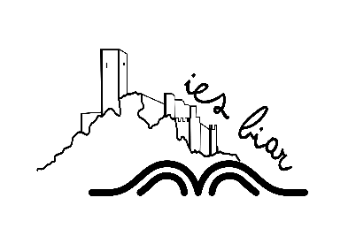
Profilirana matematicheska gymnasia “Konstantin Velichkov” (Bulgaria, Pazardzhik)
Liceo Scientifico e Linguistico Statale Principe Umberto di Savoia (Italy, Catania)
Escola Secundária de Loulé (Portugal, Loulé)
Lycée Général et Technologique Marc Bloch (France, Bischheim)

